Using Polymarket Prediction Markets to Forecast S&P 500 Daily Performance

Final Project 1 - Milestone 3
Zicheng (Chance) Xu
DSC 680: Applied Data Science
Bellevue University
Professor: Amirfarrokh Iranitalab
Date: January 17, 2025

Executive Summary
This project evaluates whether prediction-market probabilities can provide useful signals for forecasting the next-day direction of the U.S. equity market. Specifically, the goal is to predict whether the S&P 500 will be up or down on the next trading day using features derived from Polymarket markets (crowd-implied probabilities), augmented with an exogenous volatility control (VIX) and minimal SPY technical indicators. A key finding is that Polymarket’s strict daily S&P 500 “Up or Down” markets are sparse and short-lived, so the modeling approach pivots to a broader “fusion” universe of finance/economics-related prediction markets and aggregates them into topic-level signals. Using walk-forward validation, an elastic-net logistic regression model shows limited accuracy improvement over a naive baseline but a meaningful uplift in ranking performance (AUC) once VIX is included. Results vary by time period, highlighting regime dependence and the need for conservative interpretation.

Business Problem
Financial practitioners and individual investors frequently ask whether there are real-time sentiment or belief signals that can improve short-horizon market forecasts. Traditional predictors such as technical indicators, macro variables, and news sentiment can be noisy, expensive to maintain, or slow to update. Prediction markets offer an alternative: a continuously-updated probability that aggregates diverse information and incentives into a single number. The business problem addressed here is whether those probabilities can be transformed into reliable, explainable input features that improve next-day direction forecasting for the S&P 500 (proxied by SPY).

Background and History
Prediction markets have a long history in forecasting events because they aggregate information across many participants who are financially incentivized to be accurate. In economic terms, market prices can reflect collective expectations and risk assessments. Polymarket is a modern prediction market that lists contracts across finance, economics, politics, and other domains. The project’s initial hypothesis (from Milestone 1) is that market direction is driven by human belief, sentiment, and reaction to information, and those are the same forces that influence prediction markets. If prediction-market probabilities contain forward-looking signals, they may serve as informative features for systematic forecasting and trading research (Wolfers & Zitzewitz, 2004).

Data Explanation
The project uses two data families: (a) prediction-market data from Polymarket and (b) market price data for SPY and VIX from Yahoo Finance (via the yfinance Python package). Polymarket data are used to construct candidate features that represent crowd-implied beliefs, while SPY provides the forecasting target and VIX provides an exogenous volatility-regime control variable.
Polymarket market metadata were collected from the Gamma Markets API using paginated requests. For each market, the pipeline stored identifiers (event_id, market_id), the market question text, end timestamps, and activity proxies such as volume. For binary markets, the YES token identifier (yes_token_id) was extracted to enable time-series retrieval from the Polymarket CLOB prices-history endpoint. Historical YES token prices were then downloaded for a subset of markets and interpreted as probabilities on a 0–1 scale. To reduce redundant requests and support reproducibility, downloaded time-series records were cached to a single parquet file and incrementally updated.
Time alignment and frequency normalization were required because prediction markets trade continuously while SPY and VIX follow U.S. equity trading days. All timestamps were converted to UTC and aggregated to a daily key (date). From each token’s daily probability series, simple features were computed: the probability level (p), 1-day change (p_chg1), 5-day change (p_chg5), and short rolling means (p_roll5 and p_roll10). The forecasting label was created from SPY by computing next-day return (ret1_next) and a binary direction indicator (up_next). VIX was merged on the same date key and transformed into vix, vix_chg1, vix_ret1, and vix_roll5.
A feasibility check showed that strict daily ‘S&P 500 (SPX) Up or Down on <date>’ markets were available but limited to 42 markets spanning October–December 2025, which is not sufficient for training and validating a supervised model. Therefore, the project pivoted to a broader ‘fusion’ universe of finance/economics markets (67,899 total; 18,585 with identifiable YES token IDs) and then selected markets with longer continuous histories. Because raw per-market features were extremely sparse (many markets start late, end early, or trade sporadically), the analysis aggregated markets into a small set of interpretable topics using rule-based keyword matching on the question text (crypto, rates, growth/recession, policy risk). For each topic and day, the pipeline computed topic-level averages (e.g., p_mean__topic, p_chg1_mean__topic, p_roll5_mean__topic) and an activity measure (n_active__topic). This topic aggregation was used to reduce missingness and create a compact feature set suitable for modeling.
Data quality checks focused on coverage length, missingness, and leakage prevention. Markets were filtered by minimum history length (e.g., at least 120 days) and topic features with high missingness were removed, which reduced median row missingness to near zero for the retained features. The walk-forward split ensured that each test window occurred strictly after its training window. Refer to Appendix A for the detailed data dictionary, field definitions, and a summary of modeling configuration used in the notebook.

Methods
The workflow followed four steps. First, data acquisition: Polymarket market metadata was collected via paginated API calls, and time series were collected for selected markets using a cached parquet store to reduce repeated requests. Second, preprocessing: probability histories were converted to a daily frequency and transformed into simple features (level, 1-day change, 5-day change, and short rolling means). Third, feature engineering: markets were assigned to a small set of interpretable topics (crypto, rates, growth/recession, policy risk) using rule-based keyword matching on market questions; then daily topic features were constructed by averaging across markets in the same topic and tracking an activity proxy (count of active markets). Fourth, modeling: an elastic-net regularized logistic regression was trained and evaluated with walk-forward validation to approximate how the model would perform in production without leaking future information (Pedregosa et al., 2011).
After pivoting to the fusion universe, the project probed token histories and selected a set of markets with at least 120 days of daily coverage. The resulting modeling table contained 479–480 trading-day rows (depending on merges) and, after topic aggregation and missingness filtering, 12 topic features plus optional controls. Before aggregation, the raw market-feature matrix had high missingness because many markets start late, end early, or trade sporadically. Topic aggregation substantially reduced sparsity: after filtering the most-missing topics (policy risk and growth/recession were especially sparse in this sample), median row missingness dropped to near zero for the retained topic features.

Analysis
Baseline comparisons were used to set expectations. An “always up” baseline achieved 0.5875 accuracy, reflecting the empirical tendency for more up days than down days in the sample. A “yesterday sign” baseline performed worse at 0.5125 accuracy. With topic-only features, the regularized model’s mean accuracy was 0.5885 and mean AUC was 0.4766, indicating weak discrimination. Adding VIX improved mean accuracy to 0.6011 (with a best fold accuracy of about 0.74) and increased mean AUC to 0.6250, suggesting that volatility regime information helps the model rank next-day outcomes even when accuracy gains are small. Post-hoc threshold tuning did not materially improve accuracy; the best-performing threshold by average fold accuracy clustered near the default 0.50 and slightly lower cutoffs.
A more granular walk-forward setup increased the number of folds by using smaller test windows. Performance remained regime-dependent: some folds showed strong accuracy while others dropped substantially, even when AUC was acceptable. Adding minimal SPY technical features (short-lag returns, 5-day momentum, 10-day realized volatility, and a short moving-average ratio) did not change the mean metrics versus the Topics+VIX model, implying these simple price-based signals were redundant with VIX and/or too weak for next-day direction at this horizon. Coefficient inspection showed VIX-related variables were among the largest-magnitude contributors, consistent with the observation that volatility regime is informative in short-horizon equity direction modeling.

Conclusion
Polymarket provides accessible prediction-market data that can be transformed into daily features for financial forecasting research. However, strict S&P 500 daily up/down markets were too sparse to support modeling. A broader fusion approach, combined with topic aggregation, produced a usable dataset and an interpretable feature set. In this project, prediction-market topic features alone were not sufficient to outperform a naive “always up” baseline. Adding VIX produced the clearest improvement in discrimination (AUC), while simple SPY technicals did not provide incremental benefit. Overall, the results support a cautious thesis: prediction-market probabilities may provide complementary signals, but performance is unstable across time and should be validated conservatively before practical use.

Assumptions
The analysis assumes that Polymarket YES token prices are reasonable proxies for crowd-implied probabilities and that daily aggregation (UTC-based) retains meaningful signal for next-day U.S. equity moves. It also assumes that SPY is a valid, liquid proxy for S&P 500 direction and that the walk-forward split structure approximates a production setting without information leakage. Finally, the topic mapping assumes keyword rules capture the dominant theme of each market question sufficiently for aggregation.

Limitations
The primary limitation is effective sample size. Although Polymarket contains many markets, usable long-run daily histories are limited for many contracts, and strict SPX daily markets covered only a short window, impractical for ML modeling. The final model table contained fewer than 500 trading days, which constrains model complexity and increases uncertainty around generalization. Topic coverage was imbalanced (crypto and rates dominated the available long histories), which may bias the feature set toward those themes. Additionally, the approach focuses on next-day direction; small edge changes in accuracy can be difficult to detect reliably in short samples and may not translate into robust trading performance.

Challenges
Major engineering challenges included sparse strict-target markets, heavy missingness in raw market features, API pagination and rate limits, and timestamp alignment between crypto-style 24/7 markets and equity trading days. A key data-quality challenge was that different markets have different lifetimes and trading activity, producing unstable coverage. The solution was to implement caching, probe history lengths, select a stable subset, and aggregate features by interpretable topics to reduce sparsity and stabilize daily inputs.

Future Uses and Additional Applications
Future work can extend beyond next-day direction. For example, prediction-market topics may be more predictive for volatility regimes, large-move classification, or multi-day horizons where sentiment and macro expectations have more time to be priced. The same pipeline can support event studies (e.g., Fed decision markets), factor construction (topic indices), or monitoring dashboards that track the divergence between prediction-market expectations and market realizations. A larger historical sample, broader and more balanced topic coverage, and alternate targets may also increase signal strength.

Recommendations
For a production-quality version of this approach, the strongest near-term recommendation is to retain VIX or other volatility regime controls and expand the topic set with more consistent coverage. Topic rules should be refined and validated (e.g., human review for a subset) to reduce misclassification of markets. Model evaluation should continue to prioritize walk-forward validation, and performance reporting should include both accuracy and AUC to distinguish between threshold effects and ranking quality. If the goal is trading, the project should add transaction-cost-aware backtesting and compare against realistic baselines.

Implementation Plan
An implementable daily pipeline would run in three stages: (1) pull the latest market metadata and update the market universe; (2) refresh time series for selected tokens and write a single parquet cache; (3) generate daily topic features, merge with latest SPY/VIX data, and produce a forecast with model versioning. To support reliability, the pipeline should log API success rates, record coverage statistics, and alert when feature missingness exceeds thresholds. The modeling component should retrain on a schedule (e.g., monthly) and keep a holdout window for ongoing monitoring so that performance drift is detectable.

Ethical Assessment
This project uses publicly accessible data and is conducted for academic purposes, but it still has ethical risks. Prediction-market data can reflect participant biases, unequal access to information, and incentives that may not align with broad public interest. Using a model like this for trading without careful validation could encourage overconfidence or misleading claims about predictability. The project therefore treats the model outputs as research signals rather than financial advice, emphasizes walk-forward validation to reduce overfitting, and highlights limitations and uncertainty. If deployed, responsible use would require transparency about performance variability, clear documentation of data sources, and safeguards against misuse or misinterpretation.

Possible Audience Questions and Questions
- If I only remember one thing from this paper, what is the main takeaway and why does it matter?
The main takeaway is that prediction-market probabilities can be engineered into market-like features, but in this sample they do not consistently beat a simple baseline for next-day S&P 500 direction. The clearest improvement appears when adding VIX (volatility regime), which improves the model’s ability to rank outcomes (AUC) more than it improves raw accuracy. This matters because it suggests prediction-market signals may be most useful as a context/risk overlay, not a standalone “tomorrow up/down” trading rule.
- In plain language, what does a prediction market “price” mean, and why should I trust it as a signal at all?
For a binary “YES/NO” market, the YES token price behaves like a crowd-implied probability (for example, 0.62 is approximately a 62% chance of YES). It can be informative because it aggregates many participants’ beliefs and incentives into one number. However, trust should be conditional: if the market is illiquid, thinly traded, or easily influenced, the price can be noisy or biased. In this project, the price is treated as a research signal—useful to test, not automatically trustworthy.
- What is one real-world example of when this approach would have helped—and one example of when it might have failed?
A plausible “help” scenario is when prediction markets tied to rates, macro policy, or recession risk shift materially before equity markets re-price; a topic index might capture that change early and improve risk awareness for the next day. A likely “fail” scenario is a sudden shock (unexpected geopolitical event or surprise macro data) where both prediction markets and equities reprice too late, or where the relevant prediction markets are thin or slow, causing the model to lag reality.
- How would a typical investor use the results—buy/sell timing, sizing, or just caution?
Based on these results, the most reasonable use is risk management, not precise timing: for example, using the model’s output (especially when VIX indicates a different regime) to adjust exposure modestly, tighten risk limits, or reduce leverage. It is not strong enough in this study to justify aggressive all-in directional trades.
- If the signal says “up” tomorrow, how confident should I be—and what should I do differently if confidence is low?
Confidence should be modest. A classification label (“up/down”) can look decisive even when the underlying probability is near 50%. A better approach is to interpret the probability continuously: if it is near 0.50, treat it as uncertain and default to baseline behavior; if it is farther from 0.50 (and stable across days), it may justify small risk adjustments. In practice, confidence should be evaluated via calibration checks and out-of-sample stability, not just one backtest.
- What are the biggest practical obstacles to using prediction market data, and how would you handle them?
Key obstacles include (a) availability and coverage (many markets are short-lived), (b) liquidity and noise, (c) API or platform changes, (d) time alignment between 24/7 markets and U.S. trading days, and (e) feature stability as topic composition changes over time. Mitigations include caching, monitoring coverage and missingness, using robust topic aggregation, adding fallback features, and building alerts for sudden changes in market availability.
- How do you prevent the model from “looking into the future” by accident?
The two main safeguards are (1) strict time alignment—features must be computed only from information available up to that day—and (2) walk-forward validation, where each test period occurs strictly after its training period. Label construction must also avoid leakage by using next-day SPY returns only after the prediction day.
- Does this approach still work during major news events or market shocks?
It may work inconsistently. Shocks are exactly when relationships can break (regime shifts), and prediction markets can be noisy or late depending on liquidity and attention. That is why the paper emphasizes regime dependence and why VIX helps: volatility regime features can act as an alternative guardrail, but they do not guarantee robustness during shocks.
- If the prediction-market signal flips direction frequently, how should a user interpret that?
Frequent flipping usually means low signal-to-noise and higher uncertainty. A user could respond by smoothing signals (rolling averages), requiring a minimum confidence threshold before acting, or treating flips as a warning to reduce risk rather than as a trade trigger. In short: flipping is often a “don’t overreact” indicator.
10) If you had to improve this project next, what top three additions would you prioritize?
(1) Expand the sample (more history and more stable markets) to reduce uncertainty and improve generalization testing. (2) Upgrade topic mapping beyond keyword rules (for example, embeddings/topic modeling plus human spot-checks) to reduce misclassification and increase feature quality. (3) Add a transaction-cost-aware backtest and decision framework (position sizing, risk rules, calibration) so the results translate from metrics into actionable, realistic use cases, with strong ethical guardrails and clear non-advice framing.

Illustrations

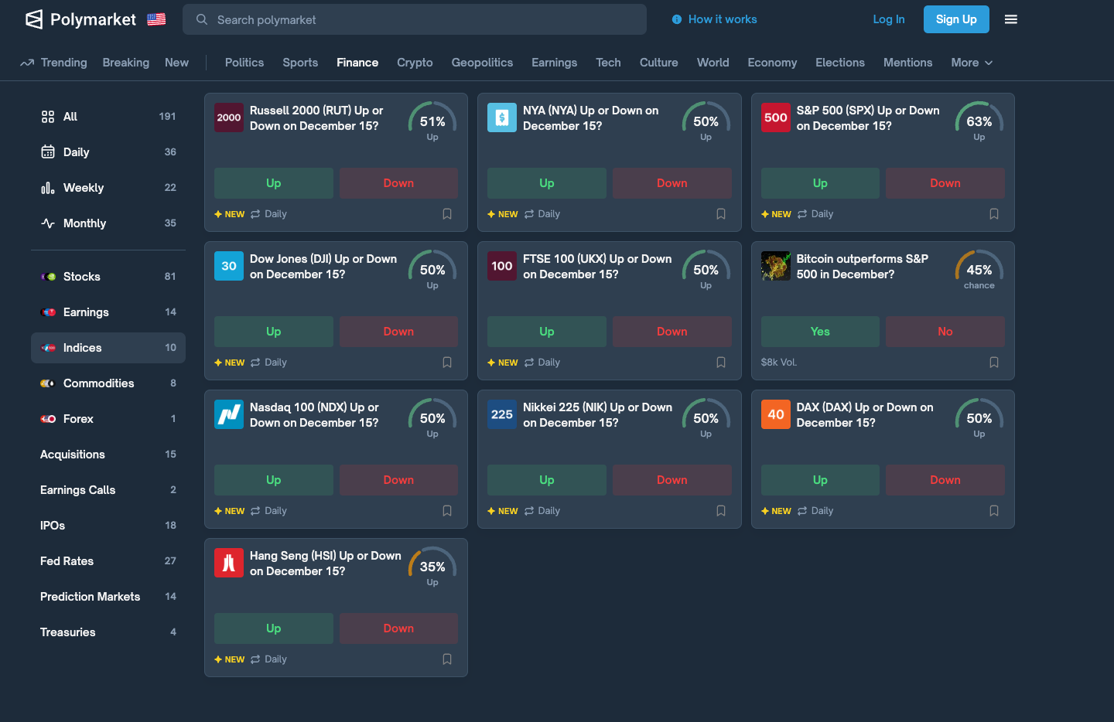
Figure 1. Example of Polymarket finance indices markets (S&P 500 daily up/down contracts).

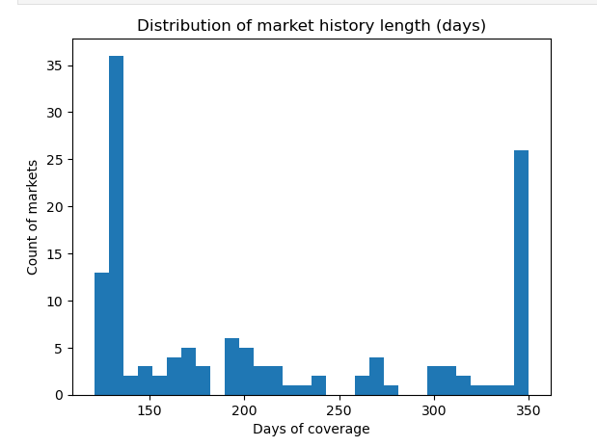
Figure 2. Distribution of market history length (days) for selected prediction-market tokens.

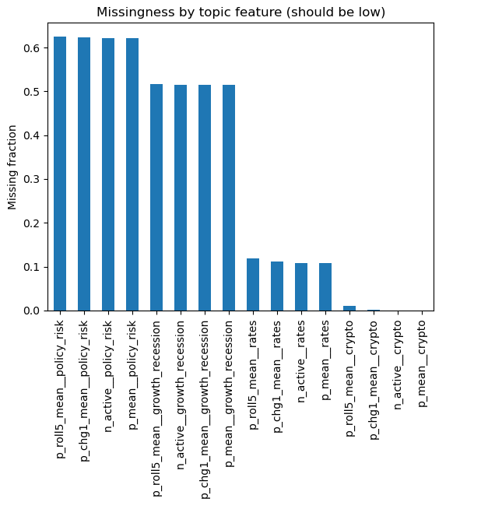
Figure 3. Missingness by topic feature (prior to missingness filtering).

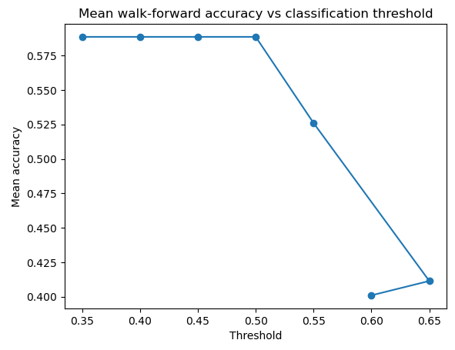
Figure 4. Mean walk-forward accuracy vs. classification threshold (post-model sensitivity).

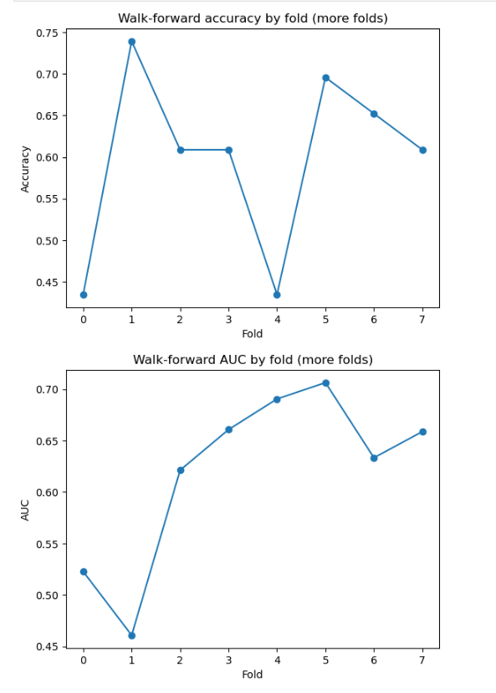
Figure 5. Walk-forward accuracy and AUC by fold using more folds (smaller test windows).
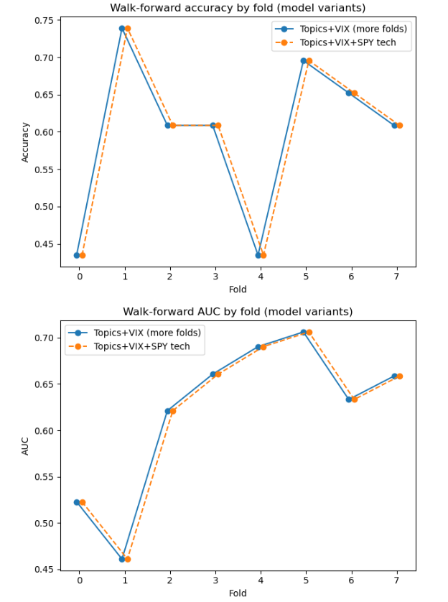
Figure 6. Walk-forward comparison of model variants (Topics+VIX vs. Topics+VIX+SPY technicals).

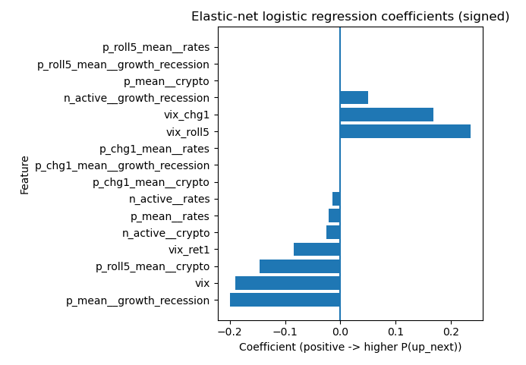
Figure 7. Signed elastic-net logistic regression coefficients for interpretability.

References
Pedregosa, F., Varoquaux, G., Gramfort, A., Michel, V., Thirion, B., Grisel, O., Blondel, M., Prettenhofer, P., Weiss, R., Dubourg, V., Vanderplas, J., Passos, A., Cournapeau, D., Brucher, M., Perrot, M., & Duchesnay, E. (2011). Scikit-learn: Machine learning in Python. Journal of Machine Learning Research, 12, 2825–2830. https://jmlr.org/papers/v12/pedregosa11a.html
Polymarket. (n.d.). Gamma markets API documentation. Polymarket Documentation. https://docs.polymarket.com/developers/gamma-markets-api/overview
Polymarket. (n.d.). CLOB timeseries and prices-history endpoint documentation. Polymarket Documentation. https://docs.polymarket.com/developers/CLOB/timeseries
Wolfers, J., & Zitzewitz, E. (2004). Prediction markets. Journal of Economic Perspectives, 18(2), 107–126.
Yahoo Finance. (n.d.). Historical market data (SPY and VIX) retrieved via the yfinance Python package. https://github.com/ranaroussi/yfinance

Appendix A: Supporting Documentation
This appendix summarizes the supporting technical details used to build the dataset and models.

A1. Key Data Objects
Polymarket market metadata (Gamma) includes event identifiers, market identifiers, questions, end timestamps, and volume metrics. Token identifiers for binary markets are used to retrieve time-series probability histories from the CLOB API. Probability histories are then aggregated to a daily frequency and transformed into features. SPY and VIX data are retrieved from Yahoo Finance and aligned by trading date.

A2. Data Dictionary (Selected Fields)
Field | Type | Description
market_id | int | Polymarket market identifier (Gamma).
question | str | Market question text (used for topic mapping).
yes_token_id | str | Token identifier representing YES outcome for binary markets (CLOB).
timestamp | datetime | Time of probability observation (UTC).
price | float | YES token price interpreted as implied probability (0–1).
date | date | Daily aggregation key for modeling and merges.
p | float | Daily probability level feature (per token).
p_chg1 | float | Daily change in probability (p[t] − p[t−1]).
p_chg5 | float | 5-day change in probability (p[t] − p[t−5]).
p_roll5 | float | 5-day rolling mean of probability.
p_roll10 | float | 10-day rolling mean of probability.
p_mean__topic | float | Daily mean probability aggregated across markets within a topic.
p_chg1_mean__topic | float | Daily mean of 1-day probability change within a topic.
p_roll5_mean__topic | float | Daily mean of rolling probability within a topic.
n_active__topic | int | Count of markets in a topic contributing data on that date.
ret1_next | float | Next-day SPY return used to define labels.
up_next | int (0/1) | Classification label: 1 if next-day return > 0, else 0.
vix | float | VIX level (volatility index).
vix_chg1 | float | Daily VIX change.
vix_ret1 | float | Daily VIX percent change.
vix_roll5 | float | 5-day rolling mean of VIX.
spy_ret1_lag1 | float | Lagged SPY daily return (t−1).
spy_ret5 | float | SPY 5-day percent change.
spy_vol10 | float | 10-day realized volatility proxy of SPY returns.
spy_ma5_ratio | float | Ratio of SPY close to 5-day moving average (trend proxy).

A3. Modeling Configuration (Summary)
Primary model: elastic-net regularized logistic regression. Evaluation: walk-forward validation with expanding training windows and fixed-length test windows (48 trading days in the initial evaluation; 23 trading days in the more-fold evaluation). Metrics: fold accuracy and AUC. Baselines: always-up and yesterday-sign classifiers.

